1. Order by clause.

Ans. select * from movies1 order by date1;

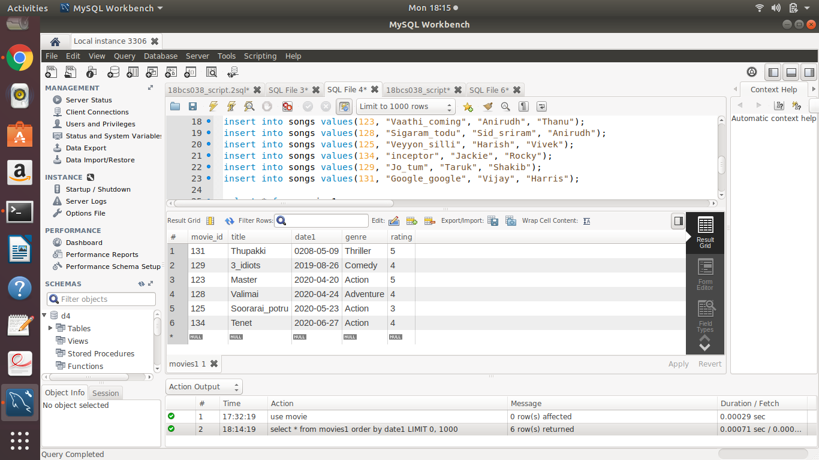

1. Group by and having.

Ans. select * from movies1 group by genre having rating >= 4;

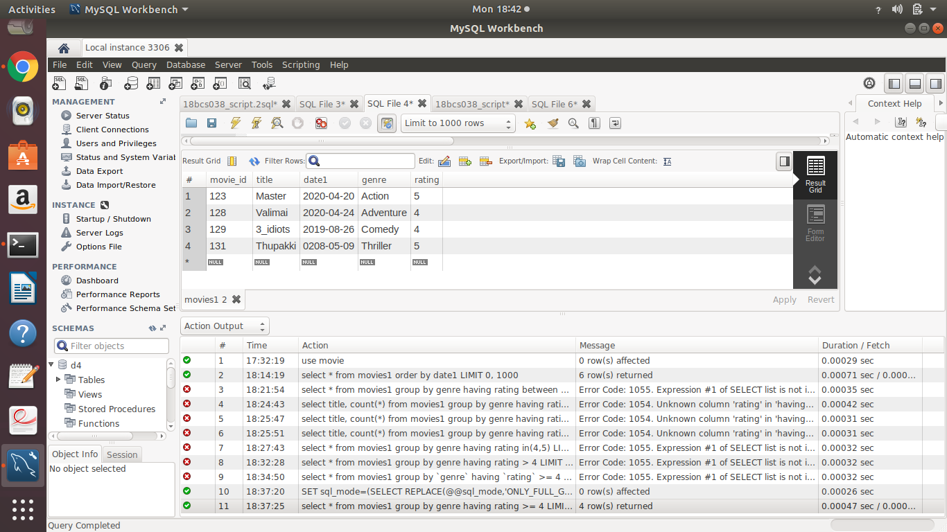

1. Aggregate functions.

Ans. select avg(rating) from movies1 where left(date1,4)="2020";

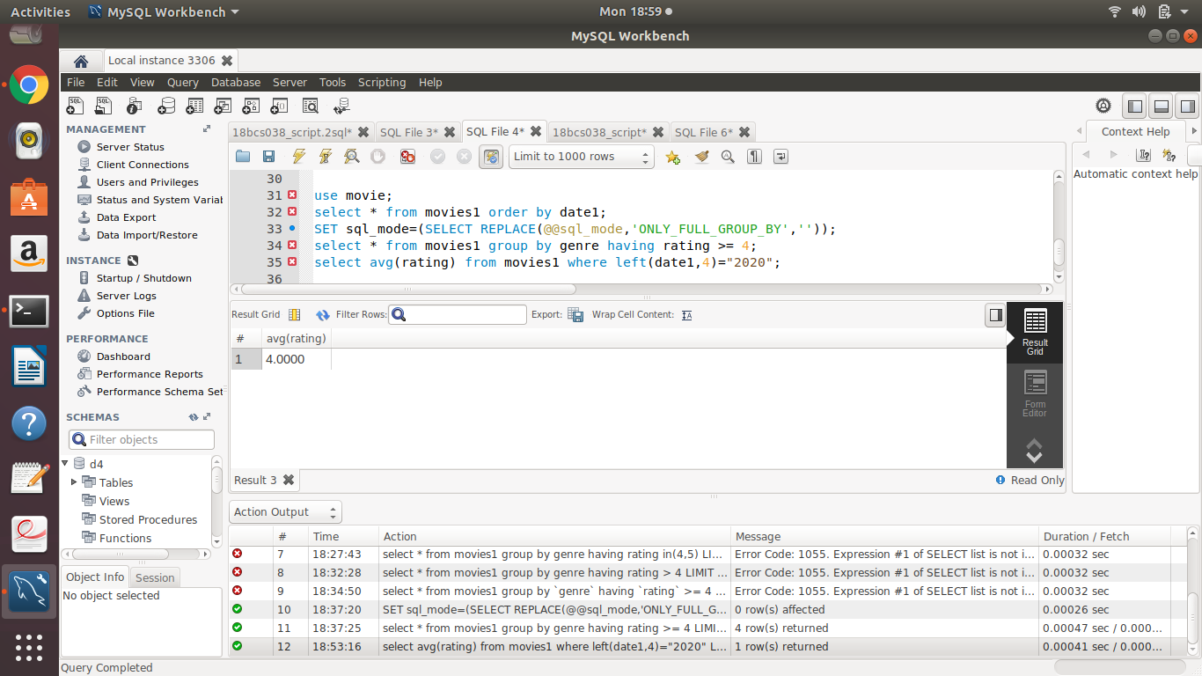

1. Logical operators especially with LIKE.

Ans. select * from movies1 where title like 'T%';

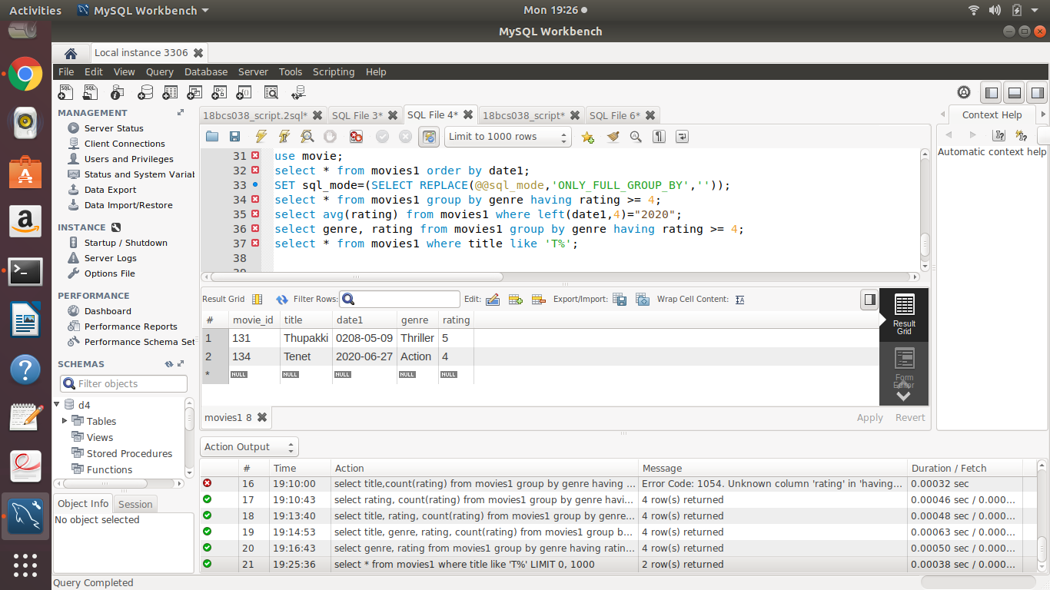

1. At least 4 nested queries specific to your Database, out of which at least 2 should have multiple subquery.

Ans.

A. select m.title, s.song_name from songs s,movies1 m where m.movie_id in (select m.movie_id where m.movie_id=s.movie_id);

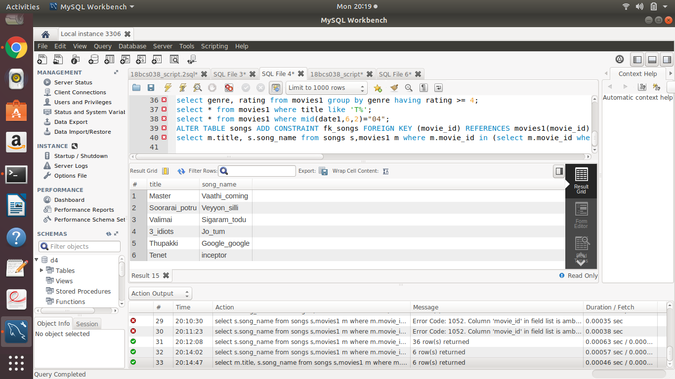

B. select m.title , s.song_name from songs s, movies1 m where m.movie_id=(select m.movie_id where m.movie_id=s.movie_id and m.title="Master");

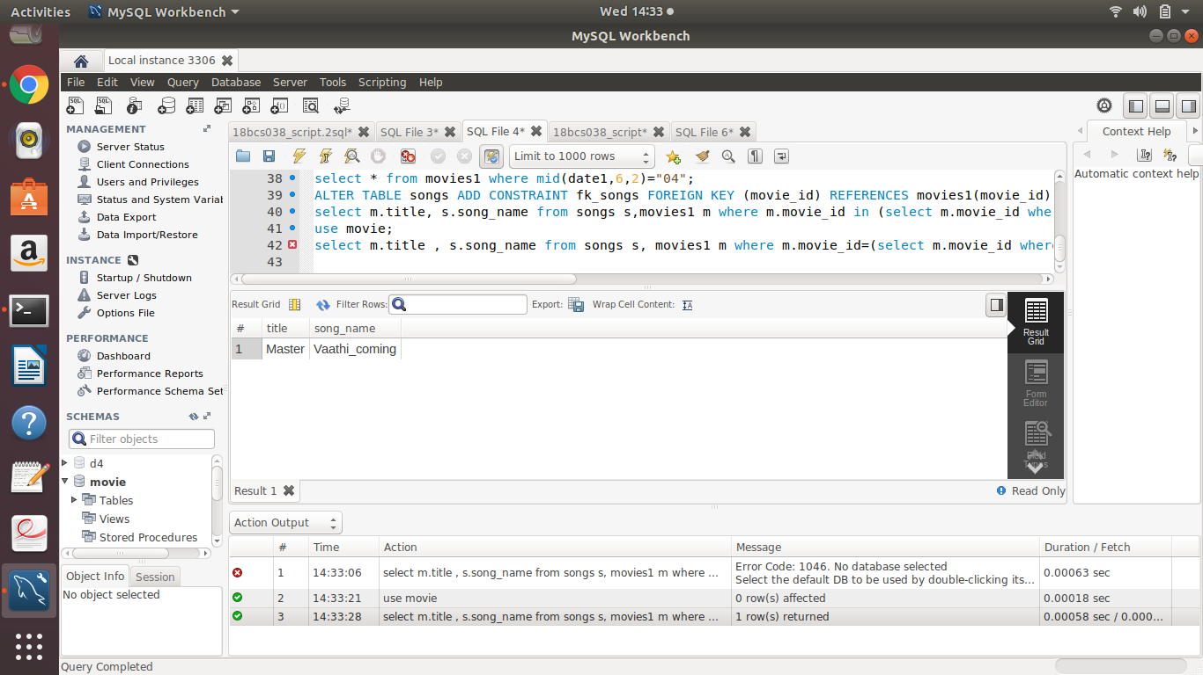

C. select concat(m.title,",", s.song_name,",", s.singer) as song_details from songs s, movies1 m where m.movie_id in( select m.movie_id where m.movie_id=s.movie_id and m.title in(select m.title where m.title="Master"));

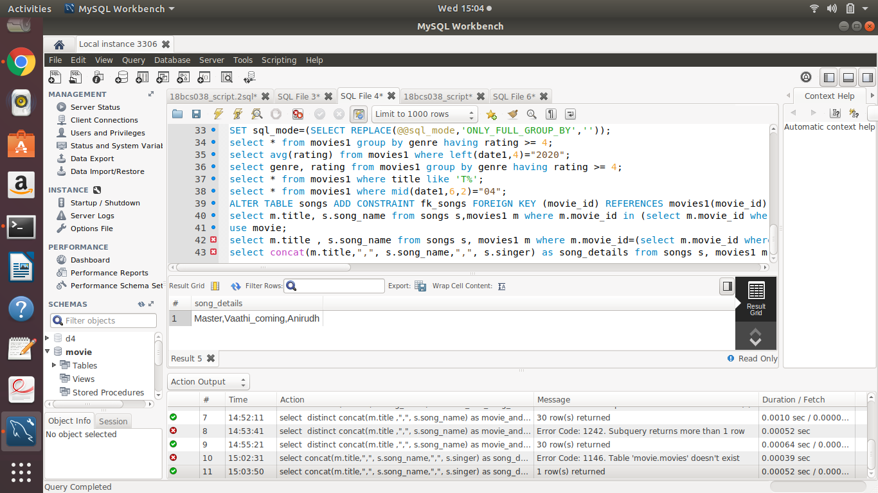

D. select concat(m.title,",", s.song_name,",", s.singer,",",composer) as artist_involved_in_action_movies from songs s, movies1 m where m.movie_id in(select m.movie_id where m.movie_id=s.movie_id and m.genre in(select m.genre where m.genre="Action"));

